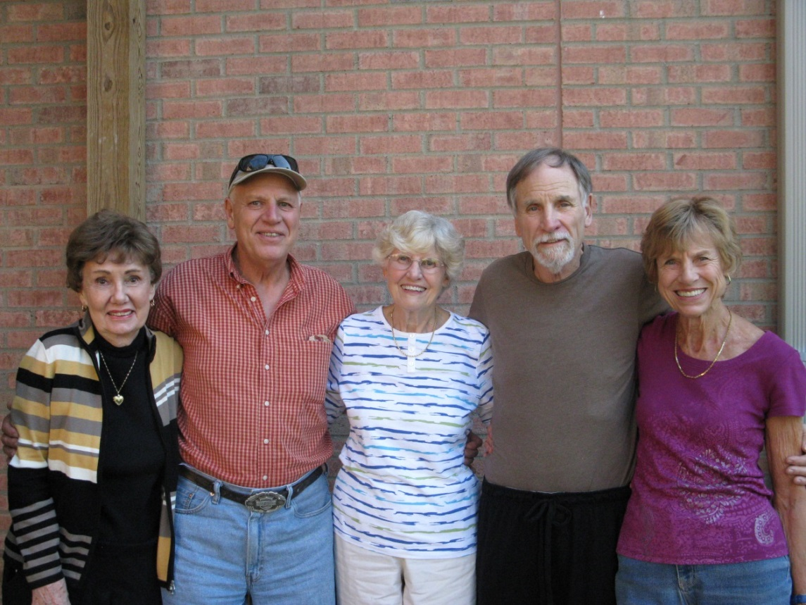

Marg, John, Lois, Nelson, Mary Jo – 2013

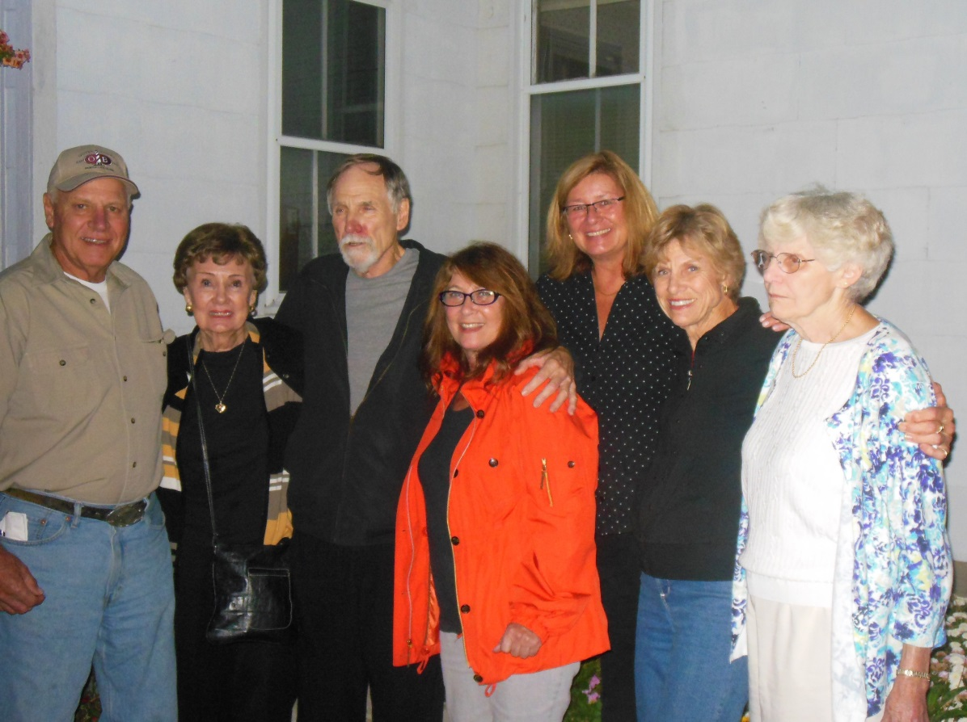

John, Marg, Nelson, Sandy, Tamey, Mary Jo, Lois – 2013